Importing Leo de Denderah from France to the UK
I had been in touch with GenieMau breeders Jean and Peter for a while and talked about my ambitions to begin breeding Bronze Egyptian Maus. Due to the extreme rarity of this colour Mau in the UK, it presented quite a challenge with acquiring suitable breeding stock. GenieMau have some spectacular queens from which they have been breeding for many years, and this gave potential for me to purchase more than one queen from them, from separate lineages. Unfortunately it still left me with the challenge of finding a suitable male.
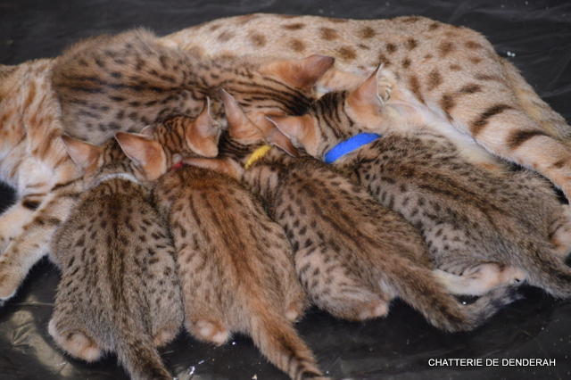
Peter and Jean spoke to Patrick le Coustumer
in France who managed to find a suitable
bronze stud from the South of France.
Unfortunately negotiations were problematic,
and this purchase soon fell through, yet Patrick
soon managed to find an even better alternative,
this time in Mulhouse, close to the Swiss border.
Target acquired, over to me.

I began my inquiries for transportation. After
looking through flight options from multiple UK
airports from Cardiff all the way to Stansted,
I finally settled on a route that would take me to Zurich, followed by a short train journey from the airport, to Mulhouse. A month before I was due to fly, I called the certain Swiss Airline to check that what I was doing was acceptable, and that the kitten would be allowed in the cabin with me. They confirmed that this was fine. Now I have had a few more catastrophes booking internet airline tickets than anyone should have experienced in one lifetime, so when it came to booking this one, I decided to speak to someone on the phone so I could get their ‘expert’ advice.

3 weeks until departure: I booked the ticket from Heathrow to Zurich, with a return including a kitten. I paid by card. I put the phone down. Departure from Heathrow scheduled Wednesday 7am.
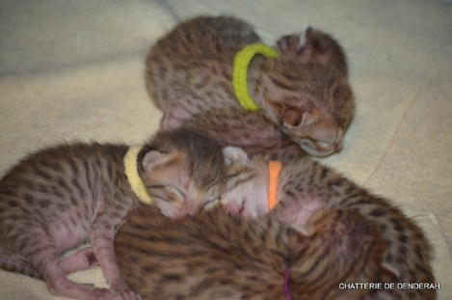
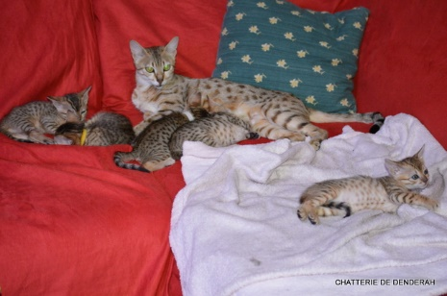
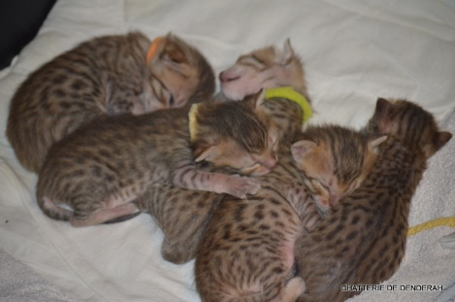

10 days until departure: Monday I receive a phone call from the Swiss Airline. They were aware that I was going to be bringing a kitten back with me. Unfortunately, they had not told me the dimensions of the cat carrier I needed to have. It needs to be small enough to fit under the seat, you see. I took the dimensions, and I went and bought a small cat carrier.
6 days until departure: Friday I receive a phone call from the Swiss Airline again. They are aware that I am bringing a kitten back with me, however I have not made the necessary payment to take the cat in the cabin. It counts as additional hand luggage, or something. So I provide my card details again and they take the payment.

23 hours before departure: I get up at 5am. The plan is to start early, so I can finish early, so I can get a good few hours of sleep before driving to Heathrow. Tuesday morning at work, I receive a phone call from the Swiss Airline, again. They are aware that I want to bring a kitten into the UK, however I am not permitted to do this. No animals are allowed in the cabin, no matter what I might have been told by however many people up to this point. Animals coming into the UK must fly as cargo, in accordance with UK law.
Right, so you can imagine how annoyed I was at this point that having been told multiple times, by multiple people, that this was acceptable, to suddenly find out that it’s not. I did not like the idea of my precious kitten travelling as cargo. ‘With the luggage?’ I ask. ‘Is that safe? Is it pressurised? What are the risks here?’. Wait for it…
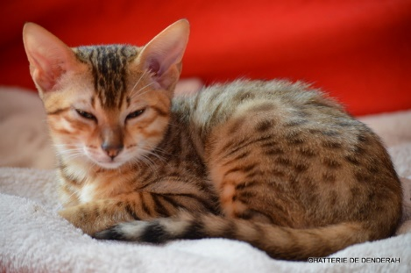
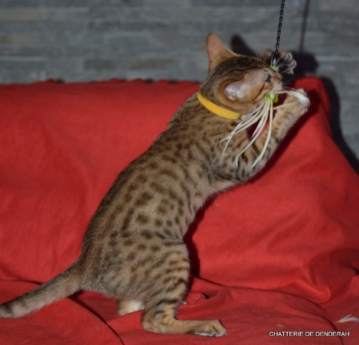
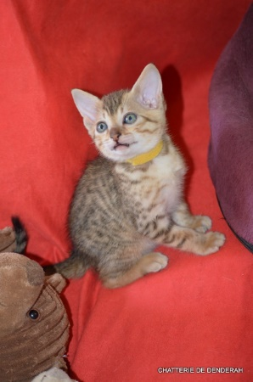

‘No sir, the cat won’t be on the same plane. It will have to take a different flight, there will be a 6 hour wait for it to arrive after you have landed, and you’ll need to collect it from a different location… and it’ll cost you an extra £350. Sorry you’ve been given the wrong information. We’ve got some new staff here’.
Apoplectic would be a fair adjective to describe my demeanour at this point. ‘New staff? That’s not my problem. That’s yours! What are you going to do then to resolve this? Are you going to cover the cost of the new flight?’
This is word for word, I kid you not…
‘Ummm, no I don’t think so’.
At which point I demanded a full refund, which I got, and slammed the phone down.
It turns out you can use the cabin to fly a cat out of, but not into the UK. Makes purrfect sense!
So, picture this. It’s 9:30am on Tuesday morning, and I’ve been up since 5am. I need to be in Mulhouse near Zurich at 10am the following morning. To top it off, I need to be in Swansea for 9am the day after for a conference with work. I don’t want to mess around the breeder in case this purchase also falls through, so what are the options? There’s only one I could think of, and that involves a long, long drive.
A call to my wife to explain the plan, she agrees it’s the only option available, and I then book a ferry ticket… by phone, explaining very clearly what I intended to do, what had just happened, and made absolutely sure that it wasn’t going to happen again. They were very helpful and sympathetic to be fair.

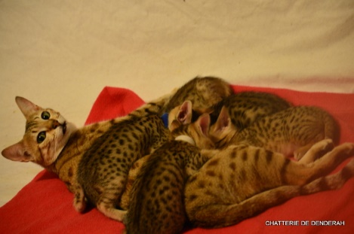
I finish work at 4pm, get home at 5pm, quick shower, change
of clothes, grab some food, a cat box, litter tray etc., and I’m
off on a 5-hour drive to Dover. I’m a fairly light sleeper, but
I’m so tired at this point that I even managed to get an hour
dozing sprawled across the seats on the ferry. I’m soon off
the other side, and driving down the AutoRoute. By the time
I finally got to Mulhouse I felt achy, tired, and rather fed up.
But I did manage to grab another hour snoozing in the car before meeting Greg Moesl to collect Leo.

Unfortunately I don’t speak French, and he doesn’t speak English, but thankfully Google Translate is utterly awesome! I think I was there close to an hour, admiring the parental maus, silver, bronze and black, as well as Leo’s siblings. I collected Leo, all his documents, and his passport. I’m not sure whether to thank Patrick or Greg for being on the ball with that one, but I guess it’s something the breeder has a responsibility to be aware of more than the buyer.
Leo turns out to be extremely vocal, which at 11am I’ll admit was quite irritating. Nutracalm? Didn’t even make a dent. Valium might have been better! I might even have used the word ‘slippers’ as a threat at one point. Eventually I decided that no matter how much I wanted him to sit on the chair beside me to gain some familiarity of me before I left for this work conference, I couldn’t cope with the noise. He was relegated to the back seat, and I put my fleece over the box to create a dark enclosure to help calm him, and also acquaint him with my smell.
Ironically, about 3 hours from Calais and I decided that if I didn’t have a screaming cat sat beside me, it was quite possible that I would fall asleep. So Leo returned to the front, and grumbled continuously (though not so vigorously) all the way to the ferry terminal. We actually arrived an hour early in the end, so I managed to grab another 1 hour nap.
We have an ongoing joke in the family that I must look like a right dodgy character. If anyone is going to get pulled out at customs, it’s always me. True to form, that’s exactly what happened. So I’m diverted to a small metal hut where a man wanders around the car with a handheld device, and asks me a few questions. Despite expecting this to be the point it all falls apart, he looks at Leo, checks I have a passport for him, comments on how beautiful he is and lets me go. Whew! I’m just glad I didn’t need to explain what those capsules full of an herb-like substance were. To you and I it’s obviously Nutracalm, but I wasn’t confident my very poor French would get ‘Cat Drugs’ across without me visiting the Gendarmerie.
Checking in at the ferry terminal was equally simple. I show the ticket, explain that I have a cat, they ask to see the documents, and then also to see the kitten which surprised me. I had to take him out of the car, and right up to the desk so they could scan his microchip. It took a few attempts, but once located and his identity verified, I was allowed onto the ferry.
No sleep this time on the ferry. Far too vocal a cat, and too many people interested in admiring him. By the time I get off the ferry in Dover on Wednesday night, it’s already dark. I have to drive all the way back to Wales, and by now I’m hanging. Driving down the M4, I had the air conditioning on full blast to keep me awake, and thought that when I got to J21 I’d pull over and have a few minutes sleep before the final push to home. I looked at the next junction sign. J19. Hmm, I was convinced I had passed junction 19 just a short while back. Never mind… but this doesn’t look like Bristol. I decide I’m going to really check the next sign.
J17! By this point I’ve been awake for 44 hours with three 1-hour naps, and I’m 1h40m away from completing a 32-hour round trip. No wonder I’m getting confused. But I know this stretch of the M4 extremely well, so losing track of junctions like this has really alarmed me. I immediately pull over and get another 30 minutes sleep.
It’s amazing what a power nap can achieve. I actually managed to drive the remaining 1h40m home with no problems. Leo was handed over to my wife and kids to welcome to the house while I went and collapsed for 4-hours sleep on the bed before getting up to travel to Swansea. By the time I finally went to bed on the Thursday night, I had gone so far beyond tired that I found it very difficult to actually sleep. I think my circadian cycle had taken a real big hit. I slept like a log at the weekend though!
So after all that, you might think that I’d never, ever import a cat again. But actually you’d be wrong. Forewarned is forearmed, and now I know what I’m in for, I can prepare.
The importation has to be by ferry. As long as the ferry is part of the plan, there’s no problem. It just takes time. And I would rather it takes a lot more hours of my time, than leave a kitten in a cargo plane.
How would I do it next time? I’d have two stops. I’d travel after work again, but sleep at Dover. I’d then drive to collect the kitten, drive back to Calais, and depending on the time either sleep at Calais or Dover, and drive the last leg the following day. Make sure vaccination card and passport are in order, and the job’s a good’un.
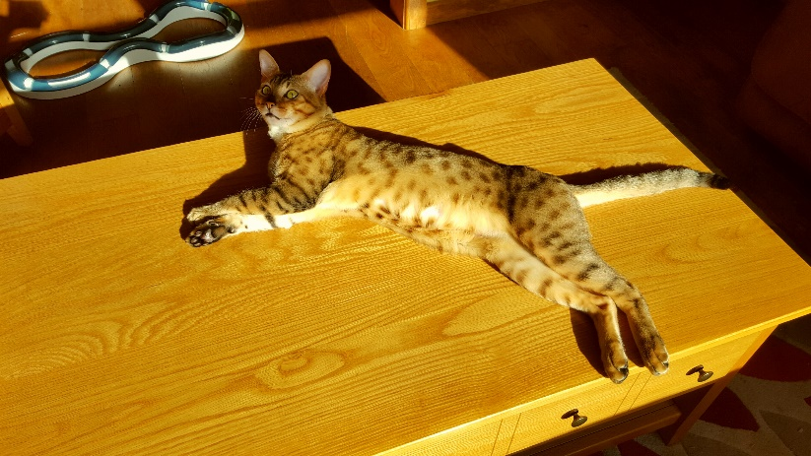
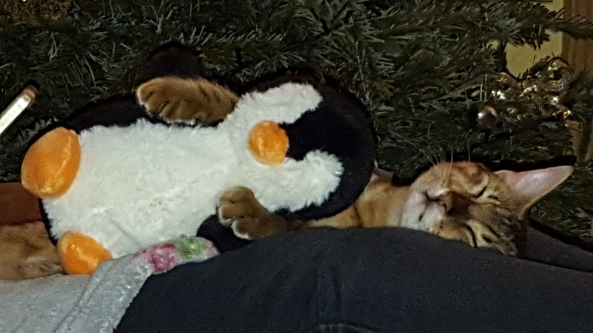
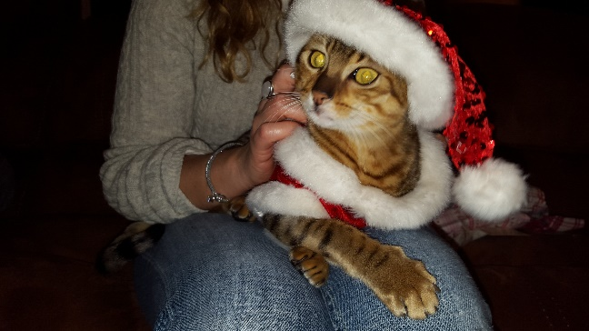
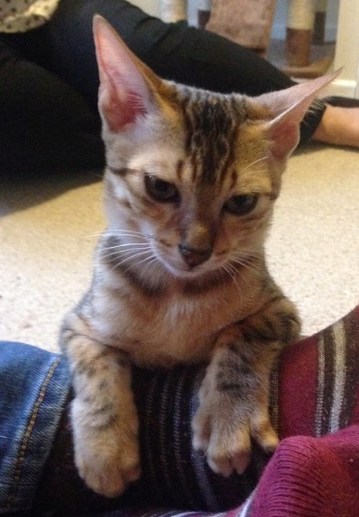
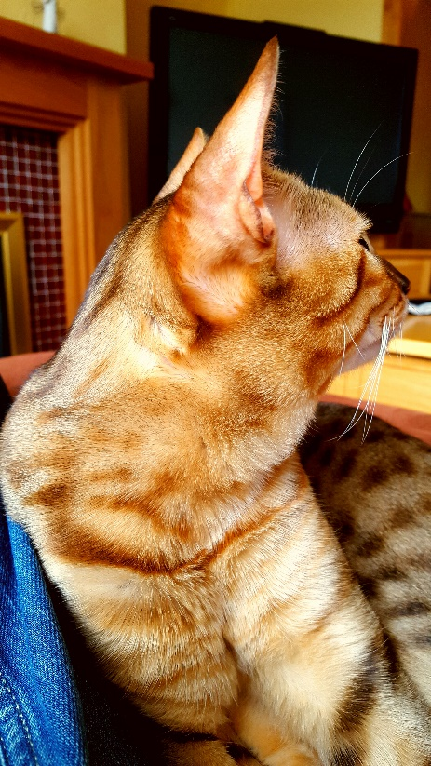
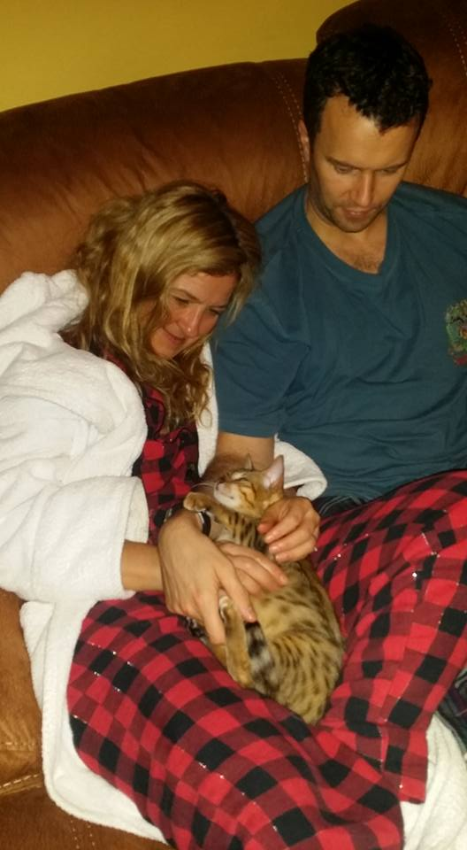
Or… I’d arrange a holiday in France, and collect the cat on the return journey. Much more fun!

